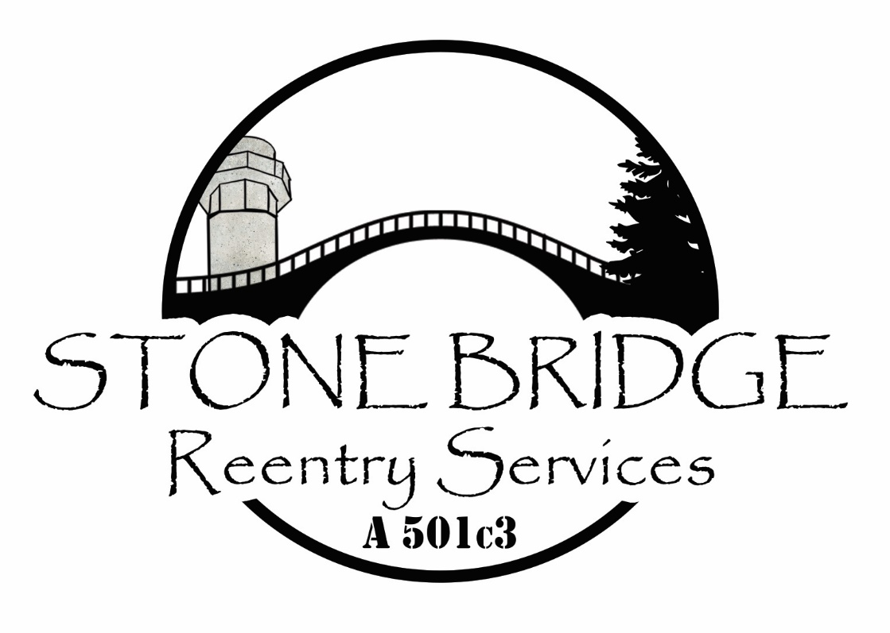

Stone Bridge Reentry Services
Application for Housing Services

Bridging the gap between incarceration and community. In addition to promoting public safety through robust reentry programs, we also strive to serve families and youth who have been negatively impacted by incarceration.

Name: _________________________________________________________________
Phone Number: _________________________________________________________
Current Address if any: ____________________________________________________
References:
- Name: ________________________________ Phone: ___________________
- Name: ________________________________ Phone: ___________________
- Name: ________________________________ Phone: ___________________
Are you currently Homeless? _____________________________________________________
Reason you are unable to obtain housing?____________________________________________________________________________________________________________________________________________________
What services are you seeking? We can get you into substance use disorder treatment as well if needed! _____________________________________________________________________
Prison/jail release date: _________________________________________________________
Who is your PO and what department are they with? _________________________________
Charges: __________________________________________________________________________________________________________________________________________________________________________________________________________________________________________

Other resources you have attempted to access, person you spoke to, and the outcome of those contacts: ____________________________________________________________________________________________________________________________________________________________________________________________________________________________________________________________________________________________________________________________________________________________________________________________________________________________________________________________________________________
If you received assistance from the above resources, how long did the assistance last?
__________________________________________________________________________________________________________________________________________________________________________________________________________________________________________
How long have you been clean/sober? ____________________________________________________________________________________________________________________________________________________________
Note** Drug and alcohol testing is a requirement of this program. Tests will be administered at random while the program pays for housing. You will be tested before any services are rendered. This is non-negotiable.
Please tell us about your goals for the next 6 months: ________________________________________________________________________________________________________________________________________________________________________________________________________________________________________________________________________________________________________________________
1 year goals: ________________________________________________________________________________________________________________________________________________________________________________________________________________________________________________________________________________________________________________________
2 year goals: ________________________________________________________________________________________________________________________________________________________________________________________________________________________________________________________________________________________________________________________
How will acceptance into the Stone Bridge program help you achieve those goals? ____________________________________________________________________________________________________________________________________________________________________________________________________________________________________________________________________________________________________________________________________________________________________________________________________________________________________________________________________________________
Are you currently in need of Substance Abuse Counseling? ________________________
Are you currently in need of Mental Health Counseling Services? _____________________

